Selkirk Triathlon Sprint
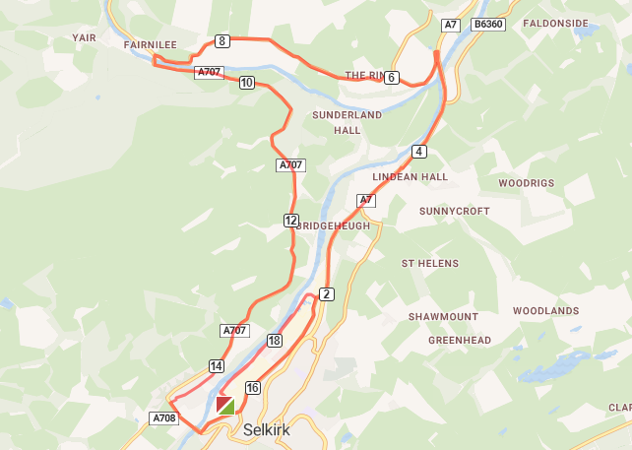
Bike Route – 19.13km

Run Route – 4.47km ( 2 laps of riverside paths)


