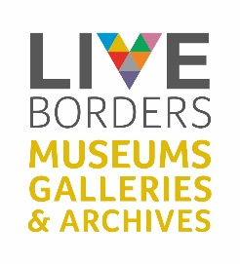
LOAN BOX FEEDBACK FORM
To enable us to provide a great service, we would appreciate your views on the experience of this Loan Box. Thank you!

Name of box: | Choose an item.
School/Organisation: | Click or tap here to enter text.
Class/Group: | Click or tap here to enter text.
Loan Date: | Start Click or tap to enter a date. | End Click or tap to enter a date.
For the following questions select a number between 1 and 5 where 5 is the best.
1 | What was your overall impression of the Loan Box? | 1☐ 2☐ 3☐ 4☐ 5☐
2 | Did you/your group find the box and objects easy to use/handle? | 1☐ 2☐ 3☐ 4☐ 5☐
3 | Were the objects relevant to the topic? | 1☐ 2☐ 3☐ 4☐ 5☐
For the following questions please use the drop-down arrow to select yes or no.
4 | Was the box available when you requested it? | Yes/No
5 | Did you have the box long enough? | Yes/No
6 | Are you aware of other Loan Box subjects/topics available from LIVE Borders Museums and Galleries? | Yes/No
7 | Would you like more information on the objects or topic of the box? | Yes/No
8 | Have you any suggestions for other subjects/topics for Loan Boxes? | Yes/No
If you answered ‘yes’ to either question 7 or 8 please expand on this in the space below.
Please leave any additional comments/feedback in the space below.

Thank you for completing this form. Please return to libstock@liveborders1.org.uk

